Superior University Gold Campus
Lab Task 5
Artificial Intelligence Lab
Name: Tasawar Hussain
Roll no: SU92-BSSEM-F24-073
1. Objective & Problem Statement
The objective of this lab is to model alternating two-player zero-sum games using game trees. We implement the Minimax search algorithm and enhance it with Alpha-Beta Pruning to eliminate unpromising branches without altering the final optimal decision. We also evaluate the impact of move ordering on pruning efficiency.
2. Task 1: Minimax Hand Trace
Game Tree Setup
- Leaf Terminal Utilities: [3, 5, 2, 9, 0, 7, 1, 8]
- Depth: 3 (Level 0: MAX, Level 1: MIN, Level 2: MAX, Level 3: LEAF)
Trace Table / Bottom-Up Evaluation
- Level 2 (MIN Nodes):
  - Subtree 1 (children 3, 5): $\min\left(3,5\right)=3$
  - Subtree 2 (children 2, 9): $\min\left(2,9\right)=2$
  - Subtree 3 (children 0, 7): $\min\left(0,7\right)=0$
  - Subtree 4 (children 1, 8): $\min\left(1,8\right)=1$
- Level 1 (MAX Nodes):
  - Left MAX Branch (children 3, 2): $\max\left(3,2\right)=3$
  - Right MAX Branch (children 0, 1): $\max\left(0,1\right)=1$
- Level 0 (Root MIN/MAX Node):
  - Root Decision: $\max\left(3,1\right)=3$
3. Task 2: Minimax vs Alpha-Beta Pruning Comparison
Search Algorithm | Root Decision Value | Total Evaluated Leaves | Efficiency Gain / Pruned
Plain Minimax | 3 | 8 | 0 leaves pruned (Full tree traversal)
Alpha-Beta Pruning | 3 | 5 | 3 leaves pruned
Key Findings: Both algorithms return the exact same optimal root value of 3. However, Alpha-Beta pruning avoids evaluating 3 unnecessary leaf nodes by triggering alpha/beta cutoffs whenever a branch is proven worse than a previously evaluated option.
4. Task 3: Branch Reordering Experiment
- Original Order: [3, 5, 2, 9, 0, 7, 1, 8] $→$ Alpha-Beta evaluated 5 leaves.
- Reordered Order (Optimal Move Order): [9, 8, 5, 3, 7, 2, 1, 0] $→$ Alpha-Beta evaluated 3 leaves.
Analysis: When the best moves are examined first, $α$ and $β$ bounds tighten much faster. This allows Alpha-Beta pruning to cut off larger subtrees early, drastically reducing the leaf evaluation count while maintaining the exact same root Minimax result.
5. Execution Screenshots
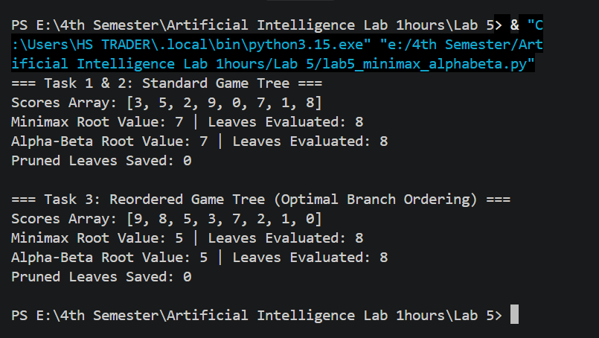6. Reflection & Conclusion
- Key Learnings: Minimax assumes an optimal opponent. Alpha-Beta Pruning optimizes performance by pruning branches that cannot influence the final decision.
- Real-World Application: Used in chess, checkers, and zero-sum board game AIs where searching the full game tree is computationally impossible.

